# Result with Discussion

The proposed Baugh-Wooley Multiplier (BWM) and Error Reduced Carry Prediction Approximate Adder (ERCPAA) filter were designed to enhance the filtering structure while reducing area and power consumption for ECG signal processing. The design was implemented using Verilog on an FPGA platform (Xilinx ISE 14.5).

Simulation Outcomes:

The proposed filter was implemented and tested on an FPGA using Verilog.

The RTL design and simulated waveform of the proposed filter were analyzed.

Comparative Analysis:

The APM-CDF-ERCPAA-BWM filter's performance was compared against existing filters (DF-4VM-CSA, DF-VMD-CLA, DF-Radix 2-LCSLA) based on parameters like lookup table (LUT) usage, speed, power consumption, area, and delay.

LUT Utilization: The proposed filter achieved a reduction in LUT utilization by 34.76%, 24.77%, and 29.06% compared to DF-4VM-CSA, DF-VMD-CLA, and DF-Radix 2-LCSLA, respectively.

Slice Count: The proposed filter showed a significant reduction in the number of slices used by 33.76%, 26.87%, and 21.66% compared to the existing filters.

Slice Registers: It also exhibited 14.6%, 23.7%, and 18.9% fewer slice registers.

I/O Pins: The proposed filter used 18.9%, 15.86%, and 12.46% fewer I/O pins.

DSP Blocks: There was a reduction of 12.87%, 18.97%, and 16.9% in DSP block usage.

Performance Metrics:

Delay: The proposed filter achieved 32.87%, 31.87%, and 29.05% less delay.

Power Consumption: Power usage was reduced by 31.76%, 25.87%, and 27.98% compared to the existing filters.

ECG Signal Processing:

Mean Square Error (MSE): The proposed method provided a significantly lower MSE for both noisy and noise-free input signals compared to existing methods.

Signal-to-Noise Ratio (SNR): The proposed filter showed higher SNR improvements for both noisy and noise-free signals.

Bit Error Rate (BER): The proposed method demonstrated a lower bit error rate compared to existing methods, indicating more accurate ECG signal denoising.

The proposed APM-CDF-ERCPAA-BWM filter demonstrated superior performance in reducing resource usage and improving signal processing quality compared to traditional methods.

For detailed figures and specific values, refer to the provided tables and figures in the full text of the results and discussion section

.

## Waveforms analysis

In this part in Fig. 20, the waveforms of original and filtered signals are displayed.

The difference of between of those three signals are showing us that the development of filter can increase a bit of SNR parameter and increase a much of RMSE parameter. And this figure is show us that this new filter who that consist of previous two filters can remove the high frequency local noise and it can remove the high frequency spike in QRS segment and this filter is smoothing the waveform in QRS segment in ECG complex. This noise removal function with removing high frequency noise provide a good condition for amplify, analysis and etc.

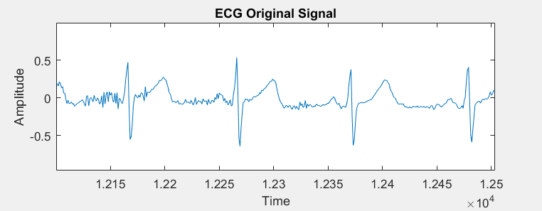

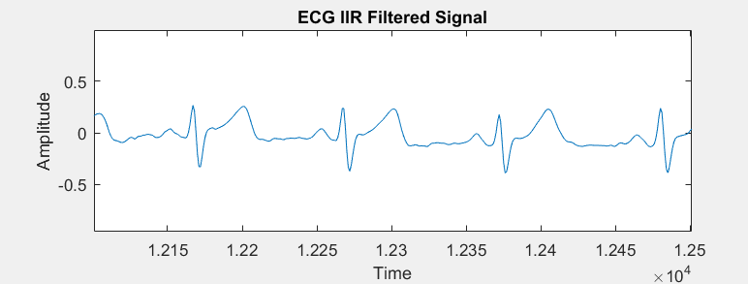

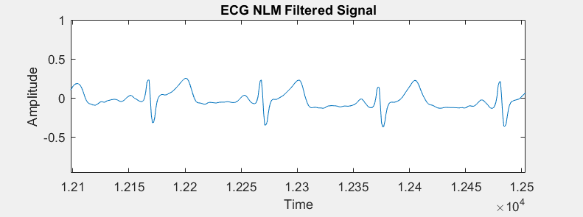

## SNR and RMSE analysis

In Fig. 21 we show the SNR parameter and RMSE parameter in the compare of output-input signals at the IIR filter at the first and NLM filter at the second. This figure shows us that SNR and RMSE can increase at compare of each two filter that proposed in past.

Fig 21. SNR and RMSE

1. SNR in ECG IIR filtered
2. SNR in ECG NLM filtered
3. RMSE in ECG IIR filtered
4. RMSE in ECG NLM filtered

